THE SPIRIT OF TENTMAKER MISSION (TM) AND FUTURE DIRECTION

Dr. Joseph Ahn (Missionary, Pastor)

We thank God for this 2022 KIMNET International Missional Leadership Forum to review and find future direction in each field of world mission. I remember it was 2007 in Guatemala when the KIMNET held a conference under the title "Tentmaker Mission." It was right after the Christian Council of Korean shared the prayer topic, “By 2030, one million Tentmaker Missionaries out of 10 million Christians!" It reflected that the Great Commission should be carried out by all churches, all clergy, and all believers, not only by the full-time missionaries but also by the Tentmaker Missionaries. UBF, cohosted the TM conference since God clearly revealed his mighty work in TM ministry through UBF that began in Kwangju, Korea in 1961 with just a few students. It reached out to over 100 campuses in Korea. It continued to reach 94 nations with 1502 TMs. Today I will present the core spirit of the UBF Tentmaker Mission and the future direction. The core spirits are: First, the Spirit of studying the Bible; Second, the Spirit of Giving; Third, the Spirit of 5 Loaves and 2 Fish (5L2F) for the Great Commission (GC). The future direction is raising national/local leaders and next generation leaders and sending out silver tentmaker missionaries.

First, the Spirit of studying the Bible
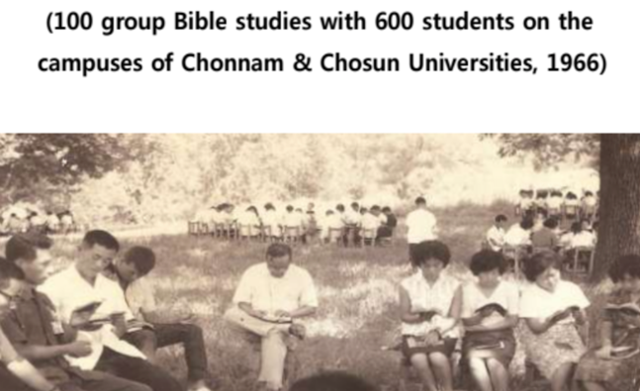
UBF stands for University Bible Fellowship. The late Dr. Samuel Lee and Msn. Sarah Barry focused on Bible Study for college students. The Bible revealed Jesus as the Savior of all the sinners of the world. The Bible taught us that this good news should be preached to all nations. Their humble and sacrificial life led others to meet Jesus and share the gospel. The Bible study was very simple and clear. It was to listen to the Word of God carefully, to meditate on it deeply, and obey even one word each time absolutely. UBF used many creative methods to plant God’s word; Small Group Bible Study, 1:1 Bible study, writing QT (Daily Bread) and Bible testimony and sharing, giving opportunities to deliver messages in small groups, international conferences, etc. In this way, we studied the Word of God almost every day for 4 years in college. Many said they studied the Bible more than studying their majors in medical school or law school. They raised a few dedicated disciples who became disciple-makers. In 1964, there were over 100 campus group Bible studies in Kwangju, Korea. Up to now the word of God has been powerfully working under the banner of “BIBLE KOREA” in many universities (86 chapters) in Korea. We experienced the Spirit of Bible study which enabled “to make all members become disciples and all members become missionaries through Bible studies.” This eventually prepared all members to obey even The Great Commission as "Tentmaker missionaries."

Second, the Spirit of Giving
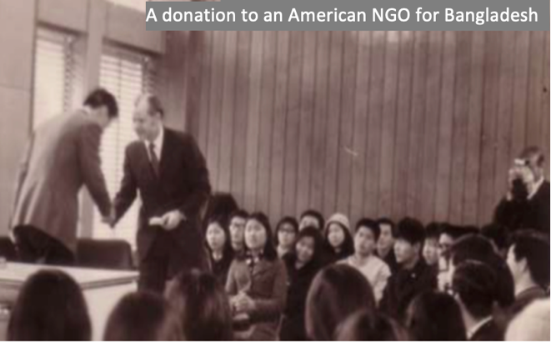
We, Koreans, especially poor students, were so accustomed to receiving many helps from other countries. We received missionaries since the 1890s. We depended on foreign aid many years especially after the Korean War (1950-1953). But the Word of God taught us, “As God gave his One and Only Son, give to others! Giving is more blessed than receiving.” When we studied the 4 gospels about Jesus’ feeding 5,000 in the wilderness, Jesus said to his disciples who had nothing, “You give them something to eat!” We accepted Jesus’ broken-hearted command to give by faith. We had to fight to overcome the deeply imbedded beggar mentality in our thought and life. We shouted, “Let us extend our leper-like shriveled hand to give.” In the early 1970s, when we read the news of Bangladesh flood refugees, we chose one American NGO to give our $20,000. To raise the fund, a medical student sold his blood. Many students sold peanuts and gum in the coffee shops and on the streets. Thus, we learned a giving spirit more and more.

Third, the Spirit of 5 loaves and 2 fish (5L2F) for the Great Commission (GC)
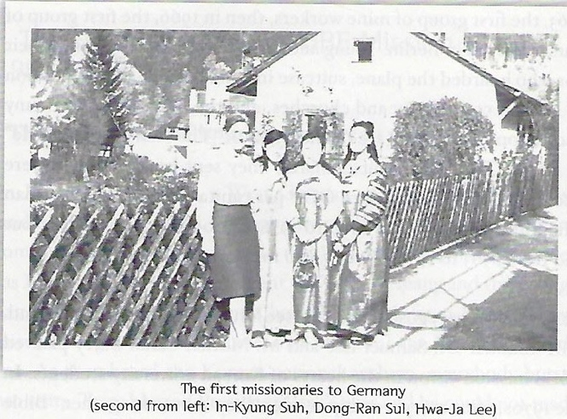
We heard about Jesus’ Great Commission at the end of the 4 gospels. “Go and make disciples of all nations!” This looked really impossible to obey. We were just like the disciples before 5,000 people in a remote place at sunset with empty pockets. How can we feed all nations while we have no way to go anywhere? But we prayed and accepted the GC because it was Jesus’ command. However, in reality, we had no money, no passport, and not enough Bible knowledge. We were the poorest college students of a missionary-receiving country. But Jesus said, “Go and see." Then the disciples brought 5 loaves and 2 fish (5L2F). Likewise, we found 3 Aid Nurses who were ready to go to West Germany in 1969. We brought them and taught the GC and ordained them as UBF's first TMs to Germany. We could not support even one penny for their air fares. However, we could pray for them day and night. It seemed Jesus was pleased and blessed them as missionaries! Whenever we heard the news of Bible studies with a few nurses on their nursing board, we praised and thanked God.
Then God opened many new ways to go abroad as TMs in 1970-80s: as medical doctors, diplomats, Taekwondo masters, agents for overseas branch offices, international students, etc. Still, some leaders who had no opportunities through their jobs, sincerely prayed. Then, they found out and brought their 5L2F. Some found and applied to go to America as ‘chicken killers.’ Several Ehwa women’s University graduates applied to a ‘Sewing Machine factory’ in Canada. Some college graduates applied to be Embassy drivers, typists, and secretaries. One SNU law school graduate who worked as a prosecutor went out as a dishwasher and a newspaper delivery boy in Los Angeles. The movement of the Holy Spirit to obey Jesus’ GC by bringing what we can find as our 5L2F moved all members’ hearts. Each of our thousands of members carried a small globe, shouting in prayer, “Go and take possession of the Land God gives!”

In the 1980s some students boldly entered Moscow by train and got a student temporary visa even before diplomatic relations were established between South Korea and the USSR. In the 1990s' IMF crisis, many mission organizations had to withdraw their missionaries. However, some of our members who lost jobs used that as their 5L2F. They applied to go as immigrant missionaries to Latin America. Jesus blessed our 5L2F so abundantly to have 12 baskets of leftovers. God blessed the first 3 aid nurses to Germany to become RNs by entering nursing college. God blessed them to marry students who began campus ministry in Germany. The ‘Sewing machine factory girls’ and ‘chicken killers’ all entered colleges. Some became Ph.D. professors to teach college students in Canada and the USA. God blessed us to send out an average of 50 TMs every year to 94 countries on all the continents. The ratio of the Korea UBF members (4,500) and the TMs (1,500) was nearly 3:1.
Did we know what was TM and how to do TM? No! We just wanted to obey Jesus’ GC. When we were totally helpless, we simply believed and obeyed Jesus’ command, “Go and see.” We went and tried not to see what we don’t have but to find what we have even 5 barley loaves and 2 smelly fish which could not feed enough for one boy as his lunch, not to mention 5,000 hungry people. We want to call this as 5L2F Spirit that turned out to be TM for Jesus’ GC. It was Jesus who blessed us each time and sent us one by one as TMs. We found out later that it was God who had done all these. Therefore, we praise God and render glory to God for UBF TM.

The future direction of Tentmaker Mission: Raising national/local leaders and next generation leaders, and sending out silver tentmaker missionaries.
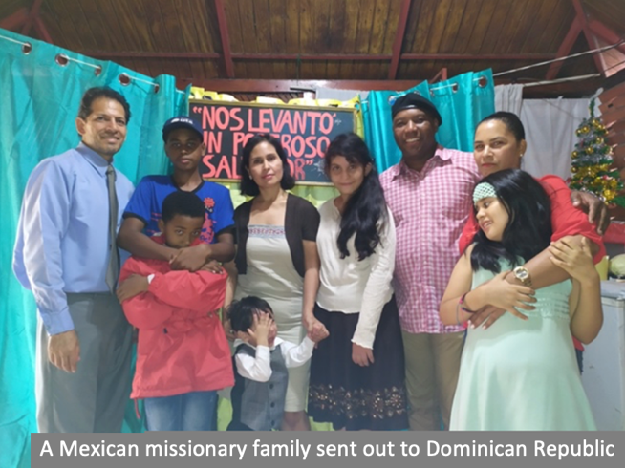
It seems now we are encountering many issues and more obstacles. In UBF, most first generations have become old. Many of them cannot stay in Africa, Asia, Latin, with no work, no visa, etc. We need to have the Sabbatical year, pension, health care, children's education, TM's spirituality, and continued education, just to name a few. Further, who will be sent out to pioneer 150 remaining countries where the Korean TM would have more difficulty getting a job? Outwardly, the recent worldwide pandemic caused so many TMs to lose jobs. A sudden Ukraine war made dozens of our TMs forcefully retreat. Other war situations exist almost everywhere. We observe our situation looks like that of 12 disciples before 4,000 people in the wilderness again after feeding 5,000 a while ago. But we could get Jesus’ wisdom and command to solve our future direction. Now we remember again how Jesus blessed us, one of the smallest mission organizations to send out so many TMs. It was to bring our 5L2F to Jesus.
We then could find out that our 5L2F can be many National/local leaders God had raised already. God had been raising already near 100 TMs from the 19 nations, including the USA, Mexico, Venezuela, Ukraine, India, South Africa, Sudan, Russia, etc. One of the best examples is here before us, P. Ron Ward, just elected as the new UBF General Director. One Korean TM met him and taught the Bible some 40 years ago when he was a freshman at Oregon State University. God trained him and raised him as the new UBF General Director as God raised Joshua after Moses. Now he is ready to lead thousands of National/Local leaders from 94 nations and whole UBF community to serve the disciple making ministry of Jesus among college students in the world.
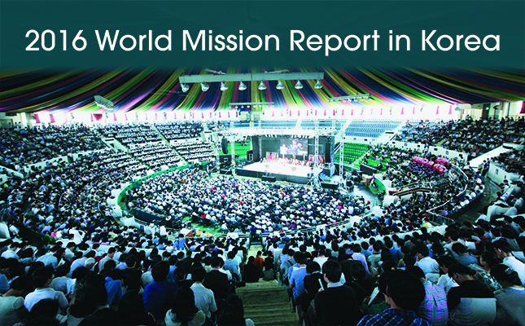
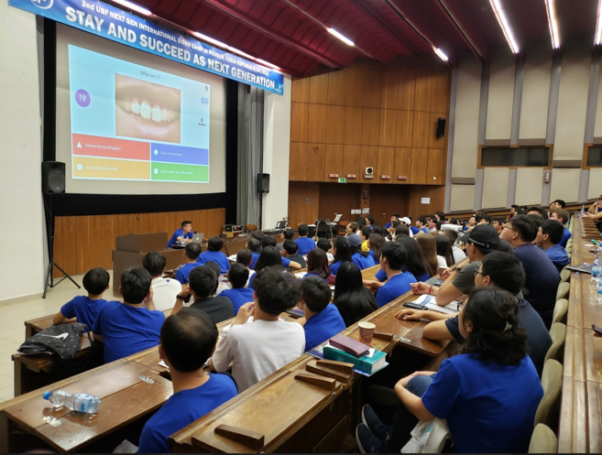
Next, God had raised our 2nd gens through 1st gens’ exemplary life of faith. Like all churches, we had issues like the so-called, “Silent Exodus of new gens." However, as time passed by, (after 20-40 years), we saw new phenomena among our new generations. Some shared their tearful life testimonies. Once they wanted to leave, for they saw how much their parents were suffering at the bottom of society with not much success in ministry. They also had the victim mentality of Isaac who was offered to God without their consent. But they also experienced the mighty God like the Exodus new gens. God provided all. Their clothes were not worn out, their food too. Therefore, they said, they would live like their parents. Some wrote in their college entrance essay saying that they love their parents as the most respectful person in the world. We see these remnants among thousands of our new gens are like Gideon’s 300 warriors. They can speak 3-4 languages fluently. They have no problems entering the mainstream they live in. Some of them already became prominent professors, MDs, and lawyers. Recently one 2nd gen MD became a president of a USA medical society of her specialty with a thousand members. Another one became an American diplomat in the Middle East. In Australia, parents serve food while new gens take care of all the programs. They preside, lead GBS, share testimonies, and even give messages occasionally during the Sunday Worship services and conferences. It was the fruits of the TM parents who honestly, humbly, sacrificially gave their families as their 5L2F for Jesus' GC. It was Jesus who blessed us with 12 baskets of leftovers. Of course, we had good programs for the new gens. For example, we have CBF (Children Bible Fellowship), HBF (High School Bible Fellowship) to help them with 1:1 Bible study and DB sharing and also parents' education courses, etc. During our 2022 Chicago area Easter conference with over 400 attendees, all speakers were new gens. In this way new gens are growing as Joshua, Caleb and Exodus second gens, as our 5L2F. We see also our Silver TMs can be our 5L2F. God already sent out Silver TMs after their retirement to many countries. Jesus has already started even before we worry about our TM future in the worsening world situations.
Why should we worry about the future TM? We may only keep finding and offering them and Jesus will surely bless UBF to go and make disciples in all 233 nations by 2041 by sending out 100,000 TMs as we pray day and night.

Conclusion: If God could bless a few people’s prayers and poor Korea UBF this much with our 5L2F, how much more God would bless all Korean Churches to raise one million TMs and feed all 5 billion unreached people before his coming if we go and see and bring our 5L2F!

University Bible Fellowship began as a student movement in South Korea in September of 1961, during a time of national turmoil. It is an international evangelical church focused on campus ministry in 94 countries in the world. https://www.ubf.org/about/origin
The Moravians had a 12:1 ratio.

